**Attributes of table**

**border** : This attribute is used to give table and cell border

**Cell spacing and cell padding**

**cellspacing :** this attribute is used to define the space between cells

**cellpadding** : Inside cell the space between content

These are table level attributes and used at table level.

**Syntax:**

<table width=”80%” border=”1” cellspacing=”20” cellpadding=”20”>

**align,valign,width,height**

**width :** This attribute is given at column level (cell). If this attribute is set one cell within column, automatically applied to all the cells within column

**height :** This attribute given at row level (tr).

**Syntax:**

**<table width=”100%” border=”1”>**

**<thead>**

**<tr>**

**<th width=”100”>text </th>**

**<th width=”100”>text </th>**

**<th width=”100”>text </th>**

**</tr>**

**</thead>**

**align :** This attribute is used to align text horizontally. The value of this attribute can be left | right | center | justify

**valign:** This attribute is used to align text vertically. The value of this attribute can be top|bottom|center

These attributes can be applied at row level(tr) and column level (td/th).

If it is applied at row level, this alignment is done for all the cells within row

**Syntax:**

<table *width*="100%" border="1" >

        <caption>Test Ranking</caption>

      <thead>

            <tr *height*="80">

                <th *width*="100" align="left" *valign*="top">Pos</th>

                <th *width*="300" align="right">Team</th>

                <th *width*="100">Players</th>

                <th *width*="80">Rating</th>

                <th *width*="400">Career Best Rating</th>

            </tr>

        </thead>

**background,bgcolor**

**bgcolor:** This attribute is used to apply the background color of table or row or cell

**background:** This attribute is used to apply the background image

**Syntax:**

**<table bgcolor=”color”>**

**<tr bgcolor=”color”>**

**<td bgcolor=”color”>text</td>**

**</tr>**

**</table>**

**Syntax:**

**<table background=”image path”>**

**</table>**

**rowspan,colspan**

These attributes are used to merge rows or columns

rowspan : This attribute is for merging rows

colspan: This attribute if for merging columns

**Example**

<!DOCTYPE *html*>

<html *lang*="en">

<head>

    <meta *charset*="UTF-8">

    <meta *name*="viewport" *content*="width=device-width, initial-scale=1.0">

    <title>IPL</title>

    </head>

<body>

    <table *width*="100%" border="1">

        <caption>Test Ranking</caption>

        <thead>

            <tr *height*="80">

                <th *width*="100" >Pos</th>

                <th *width*="300" >Team</th>

                <th *width*="100">Players</th>

                <th *width*="80">Rating</th>

                <th *width*="400">Career Best Rating</th>

            </tr>

        </thead>

        <tbody>

            <tr *height*="100">

                <td >01</td>

                <td><img *src*="images/ind.JPG" >IND</td>

                <td >Rohit Sharma</td>

                <td>1000</td>

                <td>923 v India at Edgbaston 2022</td>

            </tr>

            <tr >

            <td>02</td>

            <td><img *src*="images/eng.JPG" >ENG</td>

            <td>Joe Root</td>

            <td>872</td>

            <td>923 v India at Edgbaston 2022</td>

        </tr>

        <tr >

            <td>03</td>

            <td><img *src*="images/nz.JPG" >NZ</td>

            <td> Kane Williamson</td>

            <td>859</td>

            <td>919 v Pakistan at Christchurch 2021</td>

        </tr>

        <tr >

            <td>04</td>

            <td><img *src*="images/pak.JPG" >PAK</td>

            <td> Babar Azam</td>

            <td>768</td>

            <td>882 v New Zealand at Karachi 2022</td>

        </tr>

        </tbody>

        <tfoot>

            <tr ><th *colspan*="5" align="right">ICC Test Ranking</th></tr>

        </tfoot>

    </table>

</body>

</html>

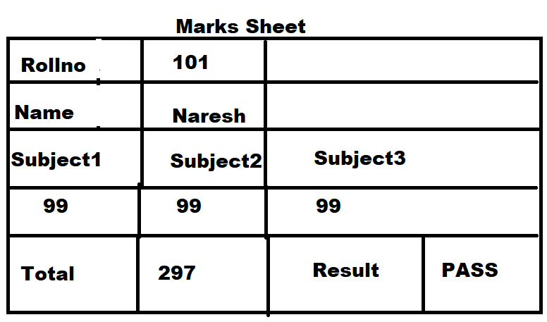

**Example**

<!DOCTYPE *html*>

<html *lang*="en">

<head>

    <meta *charset*="UTF-8">

    <meta *name*="viewport" *content*="width=device-width, initial-scale=1.0">

    <title>Document</title>

    <style>

        table

        {

            font-size: 30px;

            font-weight: bold;

        }

    </style>

</head>

<body>

    <table border="1" *width*="100%">

        <caption>Marks Sheet</caption>

        <tr>

            <td>Rollno</td>

            <td *colspan*="3">101</td>

        </tr>

        <tr>

            <td>Name</td>

            <td *colspan*="3">Naresh</td>

        </tr>

        <tr>

            <td>Subject1</td>

            <td>Subject2</td>

            <td *colspan*="2">Subject3</td>

        </tr>

        <tr>

            <td>99</td>

            <td>99</td>

            <td *colspan*="2">99</td>

        </tr>

        <tr>

            <td>Total</td>

            <td>297</td>

            <td>Result</td>

            <td>Pass</td>

        </tr>

    </table>

</body>

</html>